Scholarships Newsletter September, 2021
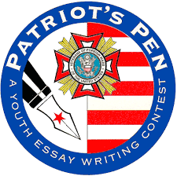
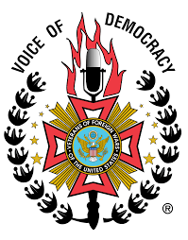
October is knocking at our door and that means that the
Voice of Democracy and Patriot’s Pen

scholarship deadlines are approaching. The deadline for entry into these scholarship contests are October 31. Students need time to research, contemplate, and enter their submissions, so please aggressively promote these scholarship opportunities! Remember, you can contact church, community, and scout leaders; school administrators and individual students; former scholarship entrants; teen centers; and members of the media (newspaper, television, and radio). Remember that advertising on Facebook and other social media platforms can be a Scholarship Report and a Media/Historian Report. They may be other reports (Americanism?) reports as well. I have 9 reports (8 of them from one Auxiliary). PLEASE get your reports to me. You can email or postal mail. If you email, it is easier to screenshot and send your photos. I know you are doing the work, just report it so we can put the crown on President Kate’ head!
Numbers are always low, and we offer multiple awards, so entering these contests is not time wasted. Also, remember the non-financial reasons to enter these contests: to have their voices heard, to appeal to colleges (“writing sample”), to learn about veterans and their service to America, and to improve their speaking skills, among other things. Please get your reports in—thank you!
Chairman Talitha Bing
9166 Lennox Pointe Drive
Charlotte, NC 28273
talitha.bing@snhu.edu
803-942-9244 Please leave a message if no answer!

