MEMBERSHIP

What is Membership? According to the Britannica dictionary, it is the state of belonging to or being a part of a group or an organization. We must maintain or membership or we will fade away. We owe too much to our Veterans to allow this to happen.
Have you wanted to star in the movies? This is your chance. The movies will be a part of the Membership Program this year. You will be a Talent Scout by recruiting new members. Promote our Auxiliary and all that we do too, to our new members and the old members.
Include all members of the Auxiliary. Everyone has something to offer. Listen to their ideas and incorporate them in the Auxiliary. We need everyone in this production. Our goal is to win the “Golden Malta Award” 100% in Membership.
Develop a membership committee. Develop a list and call, text, or email members and encourage them to pay their dues. Offer an early bird special where the regular price of dues is reduced. Mail renewal dues letters. Have a membership drive.
Use MALTA Member Resources. Take advantage of them it includes:
- VFW Auxiliary Applications
- New Member Engagement Guide
- Retention Tools
- New Member Packet

- Dues Renewal Letters
- VFW Brochure Forms

Are you ready? What role will you play in this Great Production?
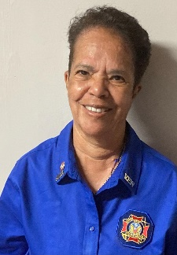

Audrey Smith
Membership Chairman
523 South Highland Forest Dr.
Columbia, South Carolina 29203
mykids.ask120@gmail.com
Cell: (803) 586-2662

