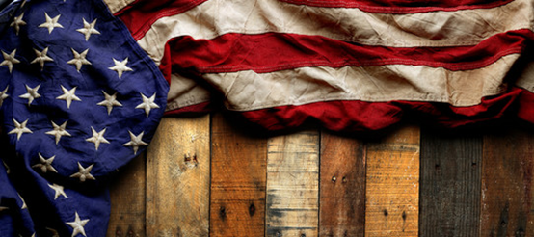
Americanism
Newsletter

January 2023
Welcome to the Americanism Newsletter for the brothers and sisters of the VFW Auxiliaries of South Carolina. The purpose of this newsletter is to provide insight as to the goals and programs that are available. It is so very hard to believe that it is the New Year and by all the reports that I have been receiving, the Auxiliaries have been working so very hard to promote Americanism.

PROGRAM GOALS –
Flag Education, Promote Auxiliary Patriotism, POW/MIA Recognition, Star Family Recognition

GOAL FOCUS OF THE MONTH –
Star Family Recognition is either a service flag or service banner in the window of a home in your area. Each flag or banner is approved by the Secretary of Defense that family members of those serving in the United States Armed Forces can display. There are three types of flags or banners: Blue Star – for family members serving during any period of war or hostilities. Gold Star – for family members who died during military operations. Silver Star for family members who were injured, wounded, or became ill during or as a result of combat. Be sure to recognize them by either dropping them a note, deliver cookies and/or bake goods. Invite them to attend a meeting and recognize them. You would be surprised how a simple gesture can mean so much to them.

PROMOTE PATRIOTISM CELEBRATING PATRIOTIC HOLIDAYS –
There are only two Patriotic Holidays left in this program year, WASHINGTON’S BIRTHDAY (PRESIDENTS DAY) THIRD MONDAY IN FEBRUARY and NATIONAL VIETNAM WAR VETERANS DAY on the MARCH 29. Be sure to fly your American Flags each day and recognize all Vietnam Veterans at your meetings.

INSPIRATION OF THE MONTH –
“Too often we underestimate the power of a touch, a smile, a kind word, a listening ear, an honest compliment, or the smallest act of caring, all of which have the potential to turn a life around.” – Leo Buscaglia
Please pass this newsletter on to your members! If you have any questions or information, you think would help benefit other auxiliaries, please let me know as I will include another area in my newsletter to answer those questions. Do not hesitate to contact me by mail, email, or phone.

Patty Williams
303 Keithwood Drive, Anderson, SC 29621
Phone 937-272-9639 – Email: hrwebe142@yahoo.com

