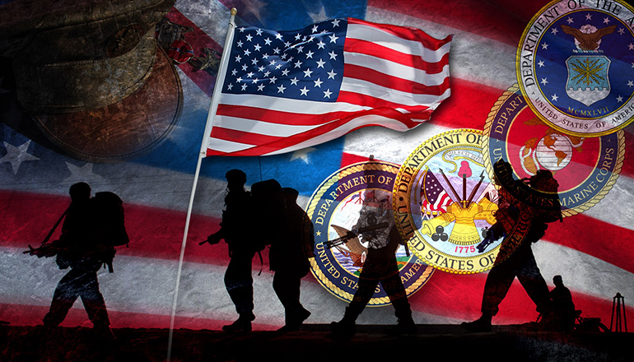
September 2021

Hello brothers and sisters of the Department of South Carolina. I hope this newsletter finds you well.
As we approach the holiday season there are several big things coming up (besides Thanksgiving and Christmas). November is National Caregivers month. Take this time to thank them for all they do for our veterans. See what can be done to help them for example; sit with their veteran while they shop or run errands, offer to shop for them, take them a meal, etc.
For Thanksgiving maybe your post can make dinner and invite veterans in your area to come. For Christmas think about sending care packages to the troops oversees or looking for a veteran family that could use help providing Christmas this year.
Remember that this time of year is hard on those who are alone, struggling, or unable to get out. Don’t forget those who gave all for us.
Veteran’s day is on November 11th. Think of ways you can honor those who served be it a parade, a special ceremony, a meal, etc.
Remember that anything you do for our veterans is a report. Please make sure to include proof for any report that you send in. This can include: pictures, newspaper clippings, and receipts of monies spent. Any activity that your auxiliary participated in after April 15th can be a report for this year.
My reporting form will be available on the website and in the president’s book. The webpage address is www.vfwauxsc.org

Sarahbeth Earnest
111 Loblolly Ct, Easley, SC 29640 - Phone: (864) 363-7765 - email: sarah.earnest86@gmail.com

